Name: ______________________________________ Date: ________________________

Student Exploration: Nuclear Decay

Vocabulary: alpha particle, atomic number, beta particle, daughter product, gamma ray, isotope, mass number, nuclear decay, positron, radioactive, subatomic particle

Alpha Particle - a helium-4 nucleus, containing two neutrons and two protons, emitted during some radioactive transformations

Atomic Number - the number of positive charges or protons in the nucleus of an atom of a given element, and therefore also the number of electrons normally surrounding the nucleus.

Beta Particle - an electron or positron emitted from an atomic nucleus in a certain type of radioactive decay.

Daughter Product - is the the result of beta decay and alpha decay.

Gamma Ray - is a high-energy, high frequency wave emitted by radioactive nuclei.

Isotope - Atoms of the same element (always same number of protons) but with different numbers of neutrons are called isotopes.

Mass Number – is the total number of protons and neutrons.

Nuclear Decay - is the tendency of an unstable nucleus to spontaneously change in composition, resulting in the emission of particles and energy.

Positron - A subatomic particle with the same mass as an electron and a numerically equal but positive charge.

Radioactive - Emitting or relating to the emission of ionizing radiation or particles.

Subatomic Particle - Any of various units of matter below the size of an atom, including the elementary particles and hadrons.

Prior Knowledge Questions (Do these BEFORE using the Gizmo.)
The chart below gives the locations, charges, and approximate masses of three subatomic particles.

Particle | Location | Charge
Proton | Nucleus | 1⁺
Neutron | Nucleus | 0
Electron | Orbitals | 1–

- The mass number of an atom is equal to the sum of protons and neutrons in the nucleus.
A helium atom has 2 protons and 2 neutrons. What is the mass number of this atom? 4

- The atomic number of an element is equal to the number of protons in each atom of the element. All helium atoms have 2 protons. What is the atomic number of helium? 2
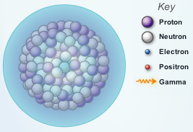
Gizmo Warm-up
While most atoms are stable, some are radioactive, which means that they have a tendency to undergo spontaneous nuclear decay. The decay of radioactive atoms generally results in the emission of particles and/or energy.

Several types of nuclear decay can be explored with the Nuclear Decay Gizmo™. On the Gizmo, check that Alpha decay and Uranium are selected.

- Click Play () and observe the alpha particle and gamma ray.
An Alpha Particle is made up of 2 protons and 2 neutrons.
Gamma rays are energetic electromagnetic waves; they are often emitted in nuclear decay.

Activity A:  Alpha decay | Get the Gizmo ready:  - Click Reset ().  - Check that Alpha decay and Uranium are selected. | 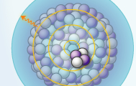

Question: How does alpha decay change the nucleus of a radioactive atom?

- Predict: As you observed in the warm-up activity, an alpha particle consists of two protons and two neutrons. How will the emission of an alpha particle affect the following?

    - The atomic number of the atom: The daughter product will be 2 less than the original.

    - The mass number of the atom: The daughter product will be 4 less than the original.

- Calculate: Turn on Write equation. What you see is an equation that shows the original uranium atom on the left. The boxes on the right represent the daughter product—the atom produced by radioactive decay—and the emitted alpha particle.

- In the top left box, write the mass number of the daughter product and press “Enter” on your keyboard. What is this number? 234
- In the bottom left box, write the atomic number of the daughter product and press “Enter.” What is this number? 90
- In the next set of boxes, enter the mass number and atomic number of the alpha particle, which has the same composition as the nucleus of a helium (He) atom. After filling in the boxes in the Gizmo, write the completed equation below: (If you’re having trouble writing in the box, re-write equation in this format: 4/2 He + 67/12 Y
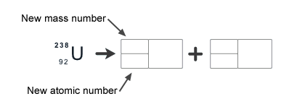
- According to your equation, what daughter product remains after the alpha decay of uranium-238? (Note: You can look up element symbols on the periodic table.)

The daughter product remaining after the alpha decay of uranium-238 is Meitnerium.

- Check: Turn on Show equation, and click Play. The equation will appear at the end of the animation. (Activity A continued on next page)
Activity A (continued from previous page)

- Practice: Click Reset, turn off Show equation, and select Polonium. Write an equation for the alpha decay of polonium, and then use the Gizmo to check your answer.
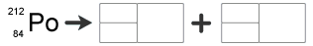

What daughter product remains after the alpha decay of polonium-212? Lead

- Practice: Click Reset, turn off Show equation, and select Radium. Write an equation for the alpha decay of radium, and then use the Gizmo to check your answer.
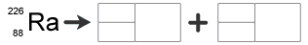

What dangerous gas is produced by the decay of radium-226? Radon

- Practice: Americium-241 is a radioactive isotope used in smoke detectors. Write an equation for the alpha decay of Americium-241 below.
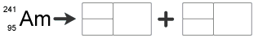
238 Np + 4 He
93 2

- Analyze: In each equation, how is the mass number on the left side of the arrow related to the sum of mass numbers on the right side of the arrow? Is this true for atomic numbers?

The mass number on the left side of the arrow is 4 greater than the daughter product. The resulting atomic numbers on the left side of the arrow is 2 greater than the daughter product.

- Summarize: In general, how can you determine the mass number of the daughter product after alpha decay has taken place? How can you determine the atomic number?

The mass number of the daughter product after alpha decay has taken place is 4 less than the original product.

Activity B:  Beta decay | Get the Gizmo ready:  - Click Reset, and turn off Show equation.  - Select Beta decay from the Type of decay menu.  - Check that Carbon is selected. | 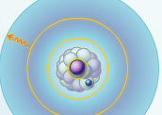

Question: How does beta decay change the nucleus of a radioactive atom?

- Observe: Click Play and watch the animation.

    - What happens to the decaying neutron during beta decay? It causes an electron to be ejected from the nucleus and transforms into a proton.
    - What is emitted from the nucleus during beta decay? An electron is emitted.

- Predict: During beta decay, a neutron is transformed into a proton and an electron (the beta particle), which is emitted. Gamma rays are often emitted during beta decay as well.

How will beta decay affect the atomic number and mass number of the atom?

The atomic number will increase by 1, and the mass number will stay the same.

- Calculate: Turn on Write equation. Fill in the first set of boxes with the mass number and atomic number of the daughter product and the next set of boxes with the mass number and atomic number of the beta particle. (Note: The atomic number of an electron is -1.)
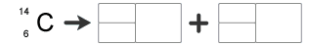

Check your answer by turning on Show equation and clicking Play. Modify your equation if necessary. What daughter product is produced by the beta decay of carbon-14? Nickel

- Practice: Turn off Show equation. Fill in the equations for the beta decay of iodine-131 and sodium-24 in the spaces below. Use the Gizmo to check your answers.
 54-Xe-131 (Xenon)
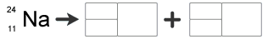 12-Mg-24 (Magnesium)

